AI-Powered Recruiter Platform
Case Study – Native World

EXECUTIVE SUMMARY
Problem → Manual recruiter-driven workflow with 54% match accuracy and operational inefficiency.
Solution → AI-Powered Recruiter Platform automating CV–JD matching, shortlisting, outreach, interview tracking, and resume improvement.
Outcome → 29-point increase in match accuracy, 70% faster screening, 60% productivity boost, and 50% revenue growth in 6 months.

1. Problem Statement

Industry / Customer Context
Company | Native World
Sector | Human Resources Services
Size | 51–200 employees
Market | India
Customer Base | Primarily B2B (SMEs & mid-sized enterprises)

Core Problem Identified
Native World operated with a recruiter-only model focused on:
- CV–JD matching
- Candidate shortlisting
- Email & WhatsApp outreach
- Interview tracking
- Candidate management
- Resume building & resume improvement support

However, the system was largely manual and fragmented.

Key Gaps
- Manual CV–JD comparison with no AI scoring
- No structured resume enhancement intelligence
- Outreach tracked separately across Email & WhatsApp
- No unified candidate pipeline visibility
- Interview feedback stored inconsistently
- No recruiter performance analytics

Processes relied heavily on:
- Excel sheets
- Email threads
- WhatsApp conversations
- Manual resume review

Supporting Data Points (Before AI Recruiter Platform)
Metric | Before
Avg. time to shortlist candidates | 5–7 days
Recruiter manual resume screening | 4–5 hrs/day
Resume–JD match accuracy | 54%
Candidate placement rate | 31%
Drop-off after interview round 1 | 38%
Monthly recruiter productivity | 15 roles/month
Client satisfaction score | 7.1/10
Revenue | ~₹32L/month

Why It Mattered (Strategic Risk)
- Slower shortlisting reduced competitive advantage
- Clients questioned candidate quality
- High recruiter dependency on manual effort
- No differentiation vs AI-first recruitment firms
- Scaling required hiring more recruiters (linear cost growth)

Projected Risk (If Unchanged)
Impact Area | Estimate | Business Consequence
B2B Client Churn | 12–18% in 12 months | Loss of recurring contracts
Opportunity Revenue Loss | ₹4–6L/month | Slower topline growth
Increase in Hiring Cost per Role | +20% | Margin compression

2. Impact of the Problem

Operational Pain
- Recruiters spending majority of time screening
- Repetitive JD–CV comparison tasks
- No standardized fitment scoring
- Interview follow-ups manually tracked
- Resume improvement done subjectively

Emotional Impact
- Recruiter fatigue & burnout
- Leadership lacking real-time visibility
- Clients pushing for faster closures
- Constant follow-ups across WhatsApp chaos

Organizational Consequences
- Inconsistent shortlist quality
- Reduced pipeline predictability
- Client escalations on candidate mismatch
- Difficulty scaling operations efficiently

Cost of Inaction
If unchanged:
- Revenue plateau
- Increased operational cost
- Declining NPS
- Lost enterprise deals to AI-enabled competitors

3. Solution Provided – AI Recruiter Platform

Solution Overview
Designed and deployed an AI-Powered Recruiter Platform focused on automating core recruitment workflows while retaining Native World's recruiter-centric operating model.

The platform unified:
- AI CV–JD matching
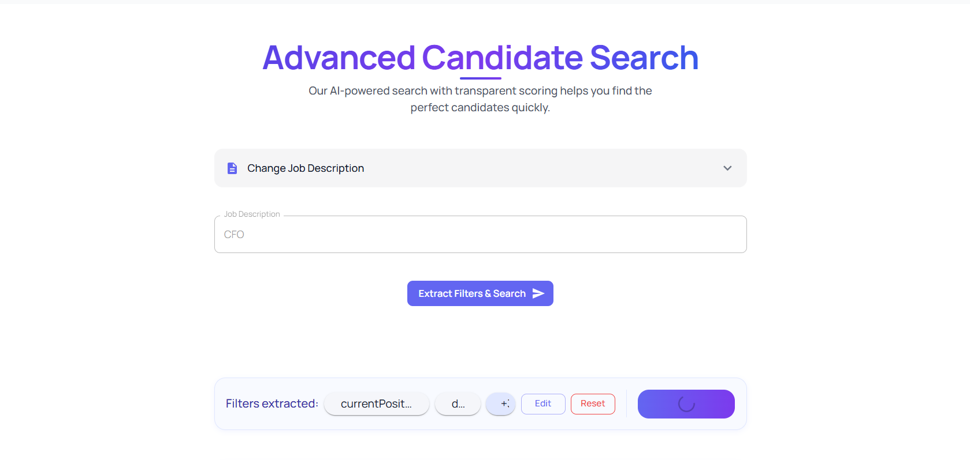
- Automated shortlisting

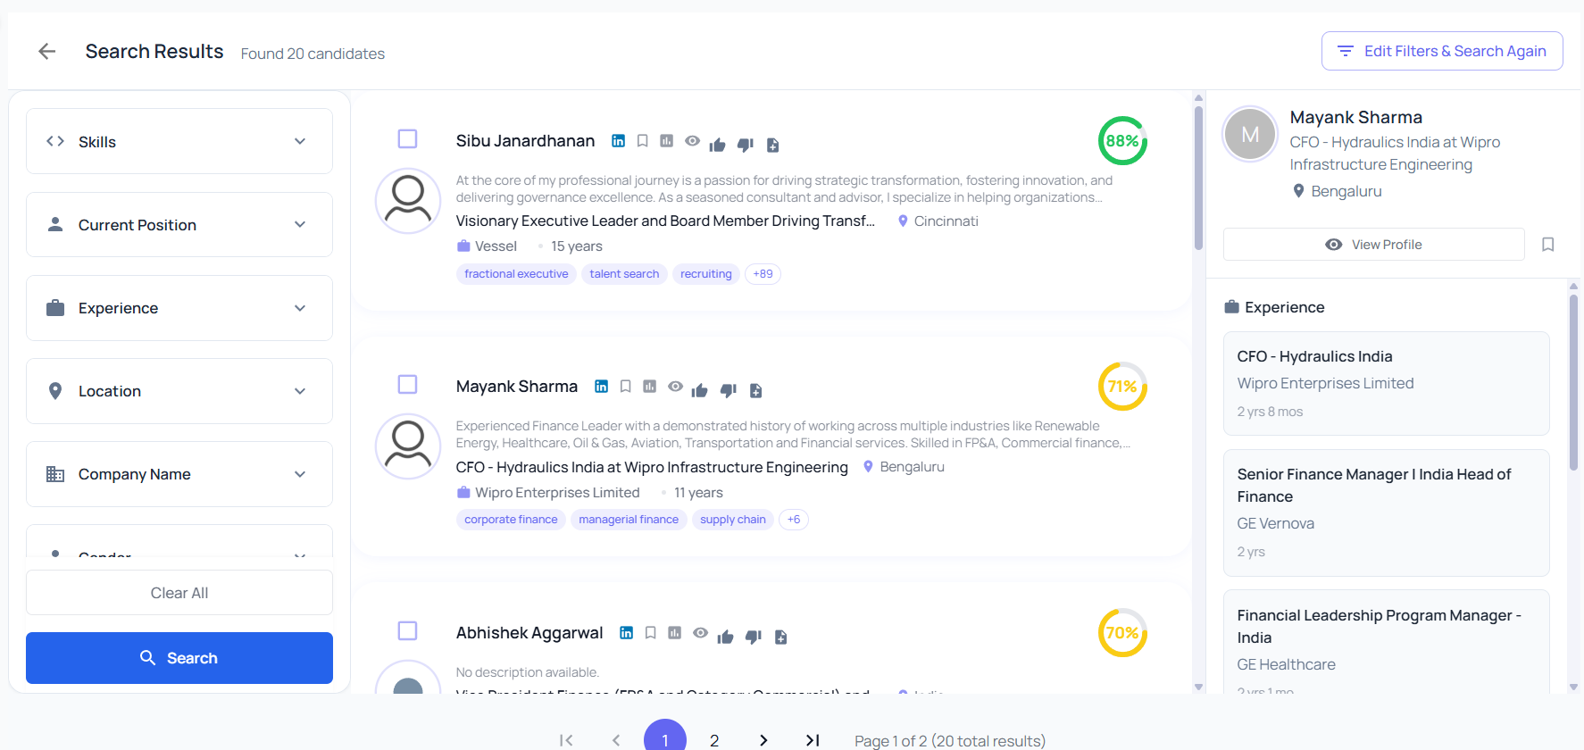

- Intelligent outreach

- Interview tracking

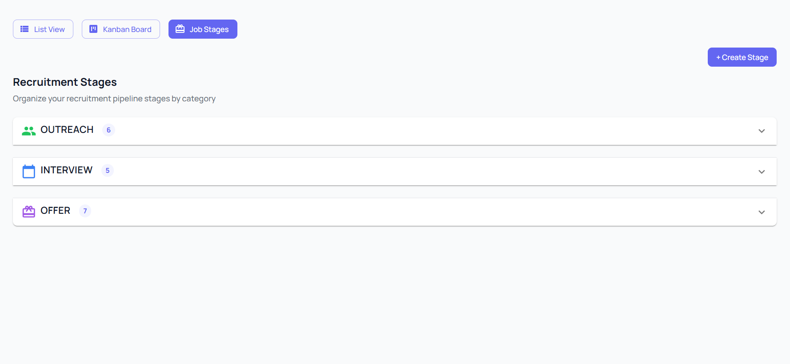

- Candidate lifecycle management

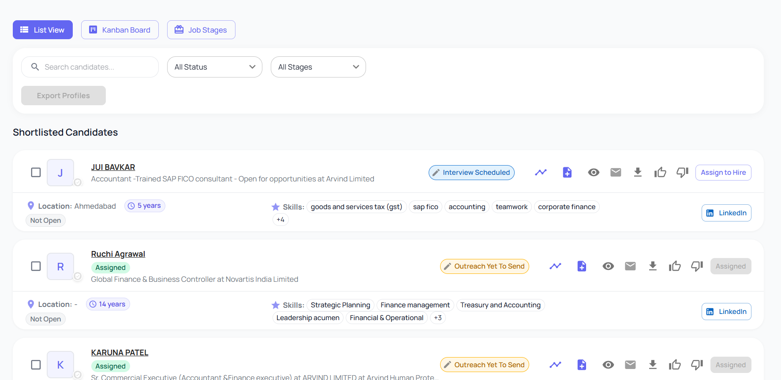

- AI Resume Builder & Resume Improver
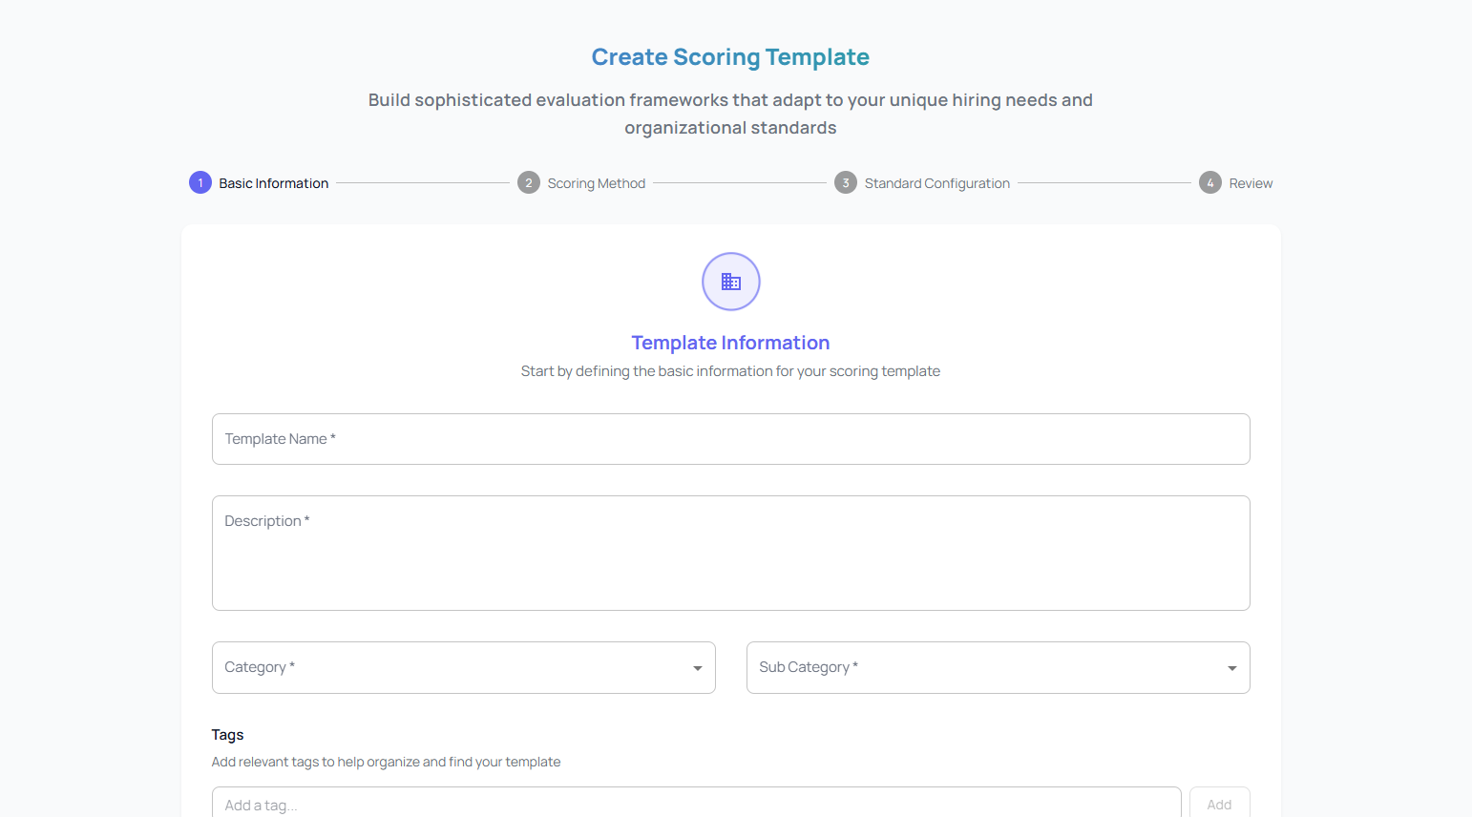

Key Features Implemented
1. AI CV–JD Matching Engine
- NLP-based semantic similarity scoring
- Skill extraction & normalization
- Experience weighting logic
- Auto-ranking of candidates
- Fitment score (0–100 scale)
Pain Relieved: Manual comparison time reduced Gain Created: Data-backed shortlists with higher precision
2. Automated Shortlisting & Recommendations
- Top-fit candidate suggestions
- Recruiter override controls
- Bulk shortlist feature
- Smart filters (skills, experience, location, salary band)
Impact: Faster decision-making with better accuracy
3. Smart Outreach Module (Email + WhatsApp Integration)
- Template-based outreach
- Bulk candidate messaging
- Auto-follow-up reminders
- Status tracking (Delivered / Replied / Scheduled)
- Unified communication log
Impact: Organized communication, reduced manual tracking
4. Interview Tracking Dashboard
- Multi-round interview flow
- Feedback capture forms
- Auto status transitions
- SLA tracking
- Client visibility reports
Impact: Structured pipeline visibility
5. Candidate Management System
- End-to-end candidate lifecycle
- Stage-wise funnel tracking
- Drop-off analytics
- Offer conversion tracking
Impact: Better funnel performance optimization
6. AI Resume Builder & Resume Improver
- Skill-based resume formatting
- JD-specific resume optimization
- Missing keyword detection
- ATS compatibility scoring
- Grammar & clarity enhancement
Pain Relieved: Low-quality resume submissions Gain Created: Higher interview conversion rates

Implementation Approach
- Timeline: 3 Months (MVP → Full Rollout)
- Architecture: Modular SaaS
- AI Layer: Resume parsing + NLP semantic matching
- Integration: Email APIs + WhatsApp Business API
- Pilot: 5 enterprise clients
- Training: Recruiter workshops + SOP redesign

Technical Architecture
- Resume parsing engine
- Skill taxonomy mapping
- NLP similarity scoring model
- Cloud-based multi-tenant setup
- Role-based access control
- Real-time analytics dashboard
- API-ready structure for ATS integrations

4. Outcome (6 Months Post-Launch)

Measurable Results
KPI | Before | After | Improvement
Time to screen 100 resumes | ~2–3 Days | ~2 hours | ↓ 70%
JD–CV match accuracy | 54% | 83% | +29 pts
Placement rate | 31% | 47% | +16 pts
Candidate drop-off rate | 38% | 22% | ↓ 16 pts
Roles closed/month | 15 | 24 | +60%
Client retention rate | 82% | 93% | +11 pts
Revenue | ₹32L/month | ₹48L/month | +50%

Strategic Impact
- 50% revenue growth within 6 months
- 25% reduction in cost per hire
- 40% improvement in recruiter productivity
- Stronger AI-driven brand positioning
- Higher enterprise deal win-rate

Human Impact
- Significant reduction in recruiter burnout
- Structured and predictable recruitment workflow
- Leadership gained real-time dashboards
- Clients experienced faster, higher-quality shortlists

